1) <!DOCTYPE html>

<html lang="en">

<head>

<meta charset="UTF-8">

<meta name="viewport" content="width=device-width, initial-scale=1.0">

<title>Document</title>

</head>

<body>

<script>

alert("hello world!!")

</script>

</body>

</html>

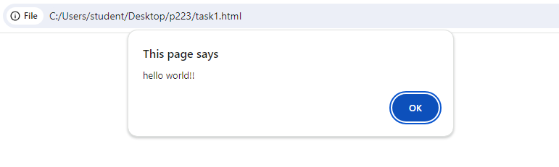

2) <!DOCTYPE html>

<html lang="en">

<head>

<meta charset="UTF-8">

<meta name="viewport" content="width=device-width, initial-scale=1.0">

<title>Document</title>

</head>

<body>

<script>

let a=10;

let b="jenishta";

let c=true;

console.log(a)

console.log(b)

console.log(c)

</script>

</body>

</html>

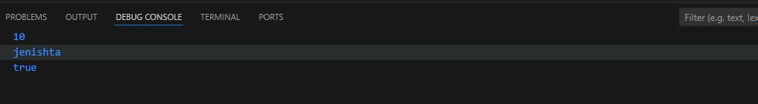

3)<!DOCTYPE html>

<html lang="en">

<head>

<meta charset="UTF-8">

<meta name="viewport" content="width=device-width, initial-scale=1.0">

<title>Document</title>

</head>

<body>

<script>

let a=10;

let b=5;

let sum=a+b;

let sub=a-b;

let mul=a*b;

let div=a/b;

console.log(sum)

console.log(sub)

console.log(mul)

console.log(div)

</script>

</body>

</html>

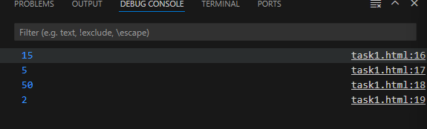

4) <!DOCTYPE html>

<html lang="en">

<head>

<meta charset="UTF-8">

<meta name="viewport" content="width=device-width, initial-scale=1.0">

<title>Document</title>

</head>

<body>

<script>

let s1="jacky";

let s2="jenish"

let ans=s1+s2;

console.log(ans);

</script>

</body>

</html>

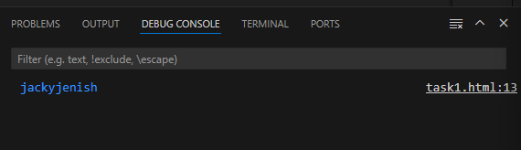

5) <!DOCTYPE html>

<html lang="en">

<head>

<meta charset="UTF-8">

<meta name="viewport" content="width=device-width, initial-scale=1.0">

<title>Document</title>

</head>

<body>

<script>

let num=10;

let str="jenishta"

let bool=true;

let un;

console.log(typeof num)

console.log(typeof str)

console.log(typeof bool)

console.log(typeof un)

</script>

</body>

</html>

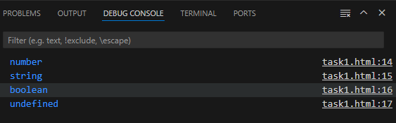

6) <!DOCTYPE html>

<html lang="en">

<head>

<meta charset="UTF-8">

<meta name="viewport" content="width=device-width, initial-scale=1.0">

<title>Document</title>

</head>

<body>

<script>

//single line js comment

/*multi

line

javascript comment*/

</script>

</body>

</html>

Explanation:

The comment are used to hide the code, so it is not execute.

Single:

the single line js comment used to only one line comment ,do not need to close.

* //

Multiple:

The multi line js comment is used to hide the multi line,need to close

* /*……….*/

7) <!DOCTYPE html>

<html lang="en">

<head>

<meta charset="UTF-8">

<meta name="viewport" content="width=device-width, initial-scale=1.0">

<title>Document</title>

</head>

<body>

<script>

console.log("hello")

console.log("jenish");

</script>

</body>

</html>

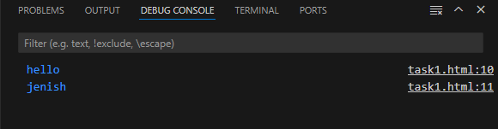

Explanation:

Both semicolon and without semicolon will work as end of the line. But here, semicolon is not mandatory.

8) <!DOCTYPE html>

<html lang="en">

<head>

<meta charset="UTF-8">

<meta name="viewport" content="width=device-width, initial-scale=1.0">

<title>Document</title>

</head>

<body>

<script>

let a=3,b=5;

for(let i=1;i<=a;i++){

for(let j=1;j<b;j++){

console.log(j);

}

}

</script>

</body>

</html>

9) <!DOCTYPE html>

<html lang="en">

<head>

<meta charset="UTF-8">

<meta name="viewport" content="width=device-width, initial-scale=1.0">

<title>Document</title>

</head>

<body>

<script>

let admin,username;

admin="john"

username=admin

console.log(username)

</script>

</body>

</html>

10)

<!DOCTYPE html>

<html lang="en">

<head>

<meta charset="UTF-8">

<meta name="viewport" content="width=device-width, initial-scale=1.0">

<title>Document</title>

<script>

console.log("jenishta")

</script>

</head>

<body>

<script>

console.log("hello")

</script>

</body>

</html>

Explanation:

yes, there is a difference between script at the top and end,if the script at the top ,first the script tag will be execute before the rest of the content.it it is at the end ,first all the html code will be execute then,script tag will execute.

11)**without “use strict”**

<!DOCTYPE html>

<html lang="en">

<head>

<meta charset="UTF-8">

<meta name="viewport" content="width=device-width, initial-scale=1.0">

<title>Document</title>

</head>

<body>

<script>

let a=10

b=a;

console.log(b);

</script>

</body>

</html>

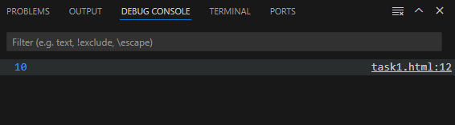

**12)With “use strict”**

<!DOCTYPE html>

<html lang="en">

<head>

<meta charset="UTF-8">

<meta name="viewport" content="width=device-width, initial-scale=1.0">

<title>Document</title>

</head>

<body>

<script>

"use strict"

let a=10

b=a;

console.log(b);

</script>

</body>

</html>

13)

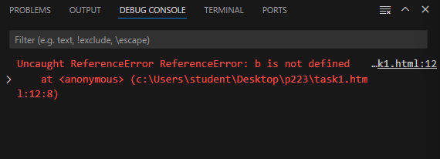

14)

<!DOCTYPE html>

<html lang="en">

<head>

<meta charset="UTF-8">

<meta name="viewport" content="width=device-width, initial-scale=1.0">

<title>Document</title>

</head>

<body>

<script>

"use strict"

let a=10;

delete a;

function hello(){

return 10;

}

hello()

delete hello;

function hello1(p){

delete p;

}

let ans=hello1(10)

</script>

</body>

</html>

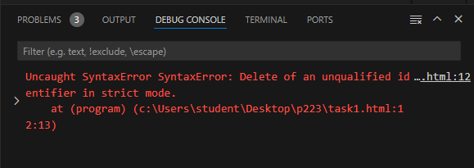

15)

<!DOCTYPE html>

<html lang="en">

<head>

<meta charset="UTF-8">

<meta name="viewport" content="width=device-width, initial-scale=1.0">

<title>Document</title>

</head>

<body>

<script>

"use strict"

var let=10;

console.log(let);

</script>

</body>

</html>

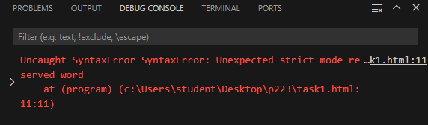

16) <!DOCTYPE html>

<html lang="en">

<head>

<meta charset="UTF-8">

<meta name="viewport" content="width=device-width, initial-scale=1.0">

<title>Document</title>

</head>

<body>

<script>

"use strict"

let a=10;

var b=10;

const c=10;

</script>

</body>

</html>

Explanation:  
var-it has no block level scope,can access outside the function.

Tolerate redeclaration

Can use the variable before declaring

Let-it has a block level scope,cant access outside the function.

Cant redeclaration.

Can use the variable after declaring.

Const-can’t reassign the value.

17)

<!DOCTYPE html>

<html lang="en">

<head>

<meta charset="UTF-8">

<meta name="viewport" content="width=device-width, initial-scale=1.0">

<title>Document</title>

</head>

<body>

<script>

const a=10;

a=20;

console.log(a)

</script>

</body>

</html>

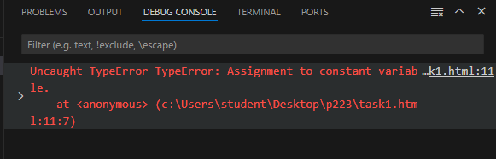

18) <!DOCTYPE html>

<html lang="en">

<head>

<meta charset="UTF-8">

<meta name="viewport" content="width=device-width, initial-scale=1.0">

<title>Document</title>

</head>

<body>

<script>

let a;

console.log(a);

</script>

</body>

</html>

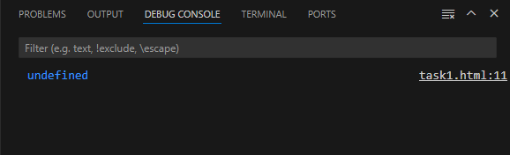

19)

<!DOCTYPE html>

<html lang="en">

<head>

<meta charset="UTF-8">

<meta name="viewport" content="width=device-width, initial-scale=1.0">

<title>Document</title>

</head>

<body>

<script>

let n=10;

let s="jeni"

let b=false;

console.log(typeof n)

console.log(typeof s)

console.log(typeof b)

</script>

</body>

</html>

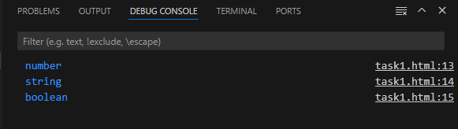

20) <!DOCTYPE html>

<html lang="en">

<head>

<meta charset="UTF-8">

<meta name="viewport" content="width=device-width, initial-scale=1.0">

<title>Document</title>

</head>

<body>

<script>

let a=10;

console.log(a)

a=20

console.log(a)

let b=10;

console.log(b)

</script>

</body>

</html>

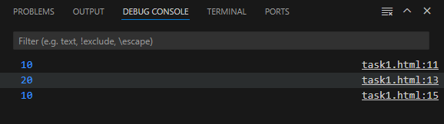

21) <!DOCTYPE html>

<html lang="en">

<head>

<meta charset="UTF-8">

<meta name="viewport" content="width=device-width, initial-scale=1.0">

<title>Document</title>

</head>

<body>

<script>

let a=10;

let b="str"

let c=null

let d;

let e=true

let f={}

console.log(a)

console.log(b)

console.log(c)

console.log(d)

console.log(e)

console.log(f)

</script>

</body>

</html>

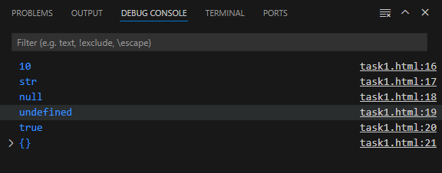

22)

<!DOCTYPE html>

<html lang="en">

<head>

<meta charset="UTF-8">

<meta name="viewport" content="width=device-width, initial-scale=1.0">

<title>Document</title>

</head>

<body>

<script>

let name=Symbol("id")

console.log(typeof name)

</script>

</body>

</html>

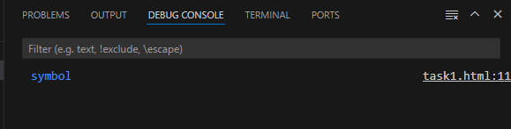

23)

<!DOCTYPE html>

<html lang="en">

<head>

<meta charset="UTF-8">

<meta name="viewport" content="width=device-width, initial-scale=1.0">

<title>Document</title>

</head>

<body>

<script>

let n=null

console.log(typeof n)

</script>

</body>

</html>

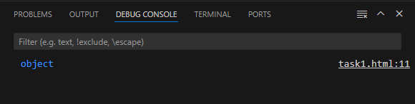

25)

var-it has no block level scope,can access outside the function, Even if declaring the variable is inside the function

Let-it has a block level scope,can’t access outside of the function.can access only inside the function otherwise it will show already has been declared.

26)

<!DOCTYPE html>

<html lang="en">

<head>

<meta charset="UTF-8">

<meta name="viewport" content="width=device-width, initial-scale=1.0">

<title>Document</title>

</head>

<body>

<script>

let s1="50"

let num1=s1*1;

console.log(num1)

let s2="100"

let num2=Number(s2)

console.log(num2)

</script>

</body>

</html>

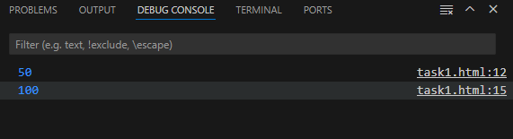

27)

<!DOCTYPE html>

<html lang="en">

<head>

<meta charset="UTF-8">

<meta name="viewport" content="width=device-width, initial-scale=1.0">

<title>Document</title>

</head>

<body>

<script>

let b1=true

let ans=String(b1)

console.log(ans)

let b2="false"

let ans2=b2+"";

console.log(ans2)

</script>

</body>

</html>

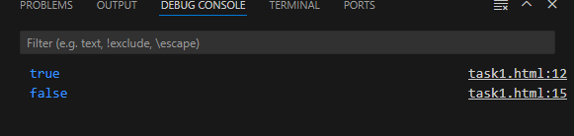

28)

<!DOCTYPE html>

<html lang="en">

<head>

<meta charset="UTF-8">

<meta name="viewport" content="width=device-width, initial-scale=1.0">

<title>Document</title>

</head>

<body>

<script>

let a=10,b=3,c=6,d=20,e=5;

let ans=a/b;

console.log(ans)

</script>

</body>

</html>

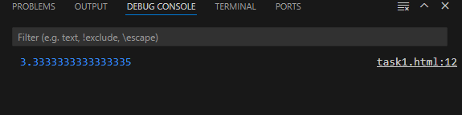

29)

<!DOCTYPE html>

<html lang="en">

<head>

<meta charset="UTF-8">

<meta name="viewport" content="width=device-width, initial-scale=1.0">

<title>Document</title>

</head>

<body>

<script>

let a=10,b=3;

console.log(a++)

console.log(++a)

console.log(--b)

console.log(b--)

</script>

</body>

</html>

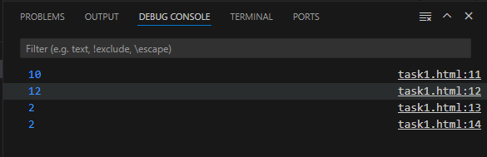

30)

<!DOCTYPE html>

<html lang="en">

<head>

<meta charset="UTF-8">

<meta name="viewport" content="width=device-width, initial-scale=1.0">

<title>Document</title>

</head>

<body>

<script>

let a=10,b=3,c=6,d=20,e=5;

let ans=a**d/b*c%a-d+a;

console.log(ans)

</script>

</body>

</html>

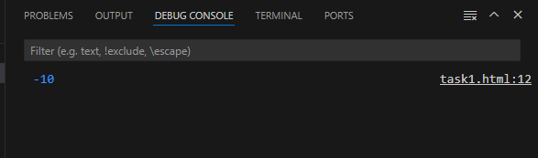

Precedence operators:

1🡺 **

2🡺 /,%,*

3🡺 +,-

31) <!DOCTYPE html>

<html lang="en">

<head>

<meta charset="UTF-8">

<meta name="viewport" content="width=device-width, initial-scale=1.0">

<title>Document</title>

</head>

<body>

<script>

let a=10,b=6;

let ans1=a>b;

let ans2=a<=b

console.log(ans1)

console.log(ans2)

</script>

</body>

</html>

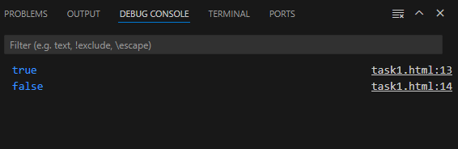

32)